1. Executive Summary
The web application was tested for security vulnerabilities based on industry standards. Critical issues such as SQL Injection and Cross-Site Scripting (XSS) were identified, which could allow attackers to access sensitive data or manipulate user sessions. Immediate remediation is recommended to ensure data protection and system integrity.

2. Technical Findings
Finding 1: SQL Injection
- Tool Used: sqlmap
- Target: /login
- Description: The login form is vulnerable to SQL Injection, allowing attackers to manipulate database queries.
- Impact: Unauthorized database access, data leakage

Finding 2: Reflected XSS
- Tool Used: Burp Suite
- Target: /form
- Payload: <script>alert(1)</script>
- Description: Input fields are not sanitized, allowing script injection.
- Impact: Session hijacking, phishing attacks

Finding 3: Weak Authentication (Optional but good for marks)
- Description: Weak passwords allowed easy login access
- Impact: Unauthorized account access

3. Findings Table
Finding ID | Vulnerability | CVSS Score | Remediation
F001 | SQL Injection | 9.1 | Use prepared statements & input validation
F002 | Reflected XSS | 6.5 | Implement output encoding
F003 | Weak Password | 7.5 | Enforce strong password policies

4. Remediation Plan
- SQL Injection:
Use parameterized queries and sanitize user inputs
- XSS:
Apply input validation and output encoding
- Authentication Issues:
Enforce strong passwords and multi-factor authentication

5. Visualization

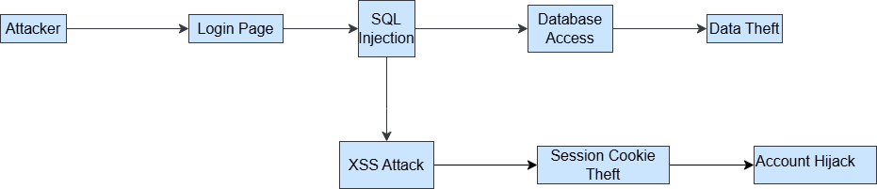

6. Non-Technical Summary
The security assessment of the web application revealed several vulnerabilities that could pose serious risks to the organization. Critical issues such as SQL Injection may allow attackers to access sensitive database information, while Cross-Site Scripting (XSS) can enable session hijacking and unauthorized user actions. Weak authentication mechanisms further increase the risk of account compromise. These vulnerabilities could lead to data breaches, reputational damage, and financial loss. Immediate remediation actions, including secure coding practices and stronger authentication controls, are recommended to enhance the overall security posture of the application and protect user data effectively.

